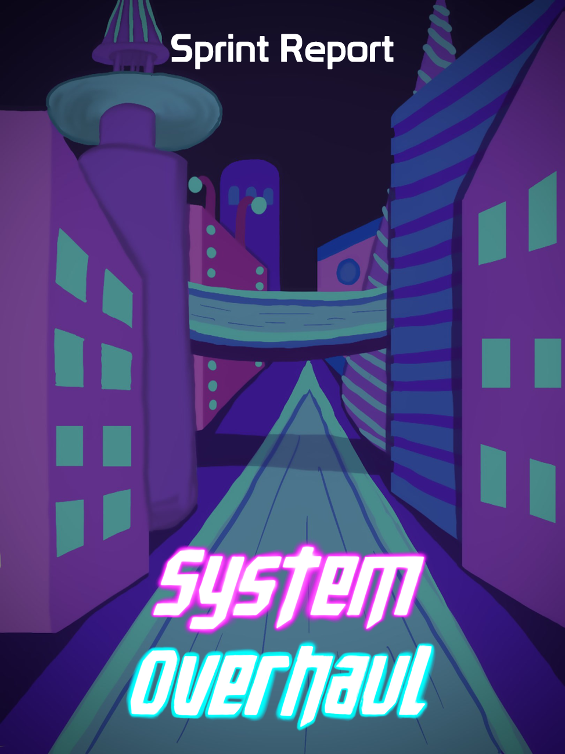





**Table of Contents**

**Previous Week** **2**

Sprint Backlog 2

Review 2

**Next Week** **3**

Sprint Backlog 4

Notes 4

# Previous Week

## Sprint Backlog

| **Tasks** | **Time Needed** | **Responsible** | **Priority** | **Stage** |
| --- | --- | --- | --- | --- |
| Player Movement | ½ hour | Gonçalo | High | Completed |
| Player Ranged Attack | 1 hour | Sheehan | High | Completed |
| Player Melee Attack | 1 hour | Sofia | High | Completed |
| Camera | ½ hour | Sheehan | High | Completed |
| Player Block | 1 hour | Gonçalo | High | Completed |

* 1. Objectives

After the first presentation we decided to start working right away on the prototype to have some functionalities already working.

No tasks were planned from the design part.

## Review

Everything went as planned, all the tasks were completed with no delays and no changes.

# Next Week

In the “Required for CG & AI” backlog the priority of the tasks didn’t change

In the “Coding” backlog our tasks with higher priority are the following:

We added the task switch weapons as well as the combine code task.

We removed the Melee Enemy Attack and Ranged Enemy Attack tasks from this backlog as they are integrated in the “Required for CG & AI” backlog.

| **Tasks** | **Time Estimate** |
| --- | --- |
| Player Jump | ½ Day |
| Radar Ability | 3 Days |
| Player Health | 1 Day |
| Switch Weapon | 1 Days |
| Combine Code | ½ Days |
| Collect Items | ½ Day |
| Checkpoints | 1 Day |

In the “3D Models & Animations” backlog the priority of the tasks didn’t change

In the “Docs” backlog the priority of the tasks didn’t change

In the “UI / 2D / Sounds” backlog the priority of the tasks didn’t change

## Sprint Backlog

| **Tasks** | **Time Estimate** | **Responsible** | **Priority** | **Stage** |
| --- | --- | --- | --- | --- |
| Player Jump | ½ Day | Gonçalo | High | Open |
| Radar Ability | 3 Days | Sheehan | High | Open |
| Player Health | 1 Day | Gonçalo | High | Open |
| Melee Enemy | 3 Days | Gonçalo | High | Open |
| Ranged Enemy | 3 Days | Sofia | High | Open |
| Combine Code  Together | 1 Day | All | High | Open |
| Switch Weapon | 1 Day | Sheehan | High | Open |

## Notes

All tasks were completed without any delay or change on the backlogs.